




Computer Programming


1.

Programming Languages

2


Computer Program

✘ Computers can perform a variety of tasks.
✘ However, they cannot perform any of them on their own.
✘ Computers have no commonsense and they cannot think.
✘ They need clear-cut instructions to tell them what to do, how to do
and when to do.

✘ A set of instructions to carry out these functions is called a computer program.

3

Programming Language
✘ The communication between two parties machines or human beings, always needs a common language or terminology.

✘ The language used in the communication of instructions to a computer is known as computer language or programming language.
✘ There are many different types of languages available today.
✘ A computer program can be written using any of the programming languages depending upon the
- Task to be performed and,
- The knowledge of the person developing the program.

4

Programming
✘ The process of writing instructions using a computer language is known as programming or coding.
✘ The person who writes such instructions is referred as a programmer.

✘ The history of programming languages is interlinked with the evolution of
computer systems.

was considered as “Father of Computer.”

was considered as the first computer programmer in the history of programming languages.

5

Evolution of






Programming languages

6

Generation of Programming Languages

✘ Programming languages have been developed in a phased manner.
✘ Each development phase has made the programming languages more user-friendly, easier to use and more powerful.
✘ Each phase of improvement made in the development of the programming languages
can be referred as a generation.
✘ The programming languages, in terms of their performance, reliability and robustness can be grouped into five different generations.

- First generation languages (1GL) – Machine Languages
- Second generation languages (2GL) - Assembly Languages
- Third generation languages (3GL)- High-level Languages
- Fourth generation languages (4GL) - Very High-level Languages
- Fifth generation languages (5GL) - Artificial Intelligence Languages

7

First Generation Language

(Machine Instruction Format)

✘ Difficult to develop and understand
✘ Not portable – H/W dependent
✘ Debugging of errors – very costly

✘ Translation free, directly executed by Computers.
✘ Speedy execution.
✘ Efficient memory utilization.
8

Second Generation Language

Mnemonics
✘ Need of ASSEMBLER
✘ Easy to develop, understand and debug
✘ Slow execution as compared to First Generation Programming Languages
✘ Not portable – still machine dependent.

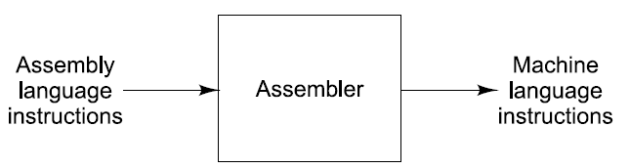
9

Third Generation Language

✘ High-level programming languages – Machine Independent
(enables to focus on logic rather than internal CPU architecture)
✘ Easy to develop, memorize, understand and debug – (specifically in English)
✘ Domain specific
✘ Translators required – Compilers/Interpreters
✘ Highly portable programs– Machine Independent
✘ More memory utilization
✘ Slow execution
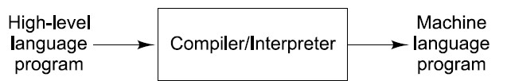
10

Fourth Generation Language

✘ Very High-level programming languages – Machine Independent
(developed to reduce time, cost and effort needed to develop different S/W applications)
✘ Easy to develop, memorize, understand and debug – (specifically in English)
✘ General-purpose programming languages – develop application related to any domain
✘ Database management specific concept implementation
✘ Highly portable
✘ More memory requirement
✘ Slow execution

11

Fifth Generation Language

✘ Focus on constraint programming – specify the solution rather than method/algorithm of
finding the solution
✘ Employed in the field of Artificial Intelligence (AI), Machine Learning (ML), Artificial Neural Network (ANN), Data Science etc.
✘ Database management specific concept implementation
✘ Easy to develop, memorize, understand and debug – (specifically in English)
✘ Highly portable

12

Characteristics of good Programming Language

✘ Allow the programmer to write simple, clear and concise programs.
✘ Language glossary should be very close to the one used in human languages
✘ Rich documentation of function libraries
✘ Allow focus only on design and implementation
✘ Must make efficient use of memory and other computer resources.
✘ Provide necessary tool for development, testing, debugging, and
maintenance of the program.
✘ Platform independent

13

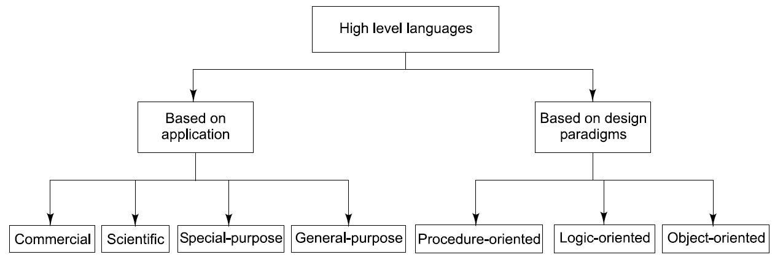
Categorization of high-level Languages

14

Commercial Languages
✘ COBOL: strong file handling

✘ Dedicated to the commercial domain and specifically designed for solving business- related problems.
✘ For processing and handling the data related to payroll, accounts payable and tax handling applications.

15
capabilities and support for business arithmetic operations

✘ PL/B: Programming language for Business

Scientific Languages

✘ Designed for solving scientific, and mathematical problems.
✘ For performing complex calculations
during scientific research.

16
✘ FORTRAN: Performing various numerical and scientific calculations.

General-purpose Languages

✘ Developing different types of software applications regardless of their application area.

17
✘ BASIC
✘ C
✘ C++
✘ JAVA

Special-purpose Languages

✘ Performing dedicated functions
✘ Support particular area only
✘ SQL: Designed to interact with the database programs only.

18

Procedure-oriented Languages
(Imperative Programming languages)

✘ Procedure contains a series of instructions
for performing specific tasks.
✘ One procedure can call other procedure during the program execution.
✘ Emphasis is on procedure not on the data.
✘ Code in the form of procedure can be used any number of times using procedure name.

19
✘ FORTRAN
✘ ALGOL
✘ C
✘ BASIC
✘ Ada

logic-oriented Languages

✘ Uses predicate logic to describe nature of a problem by defining relationships between rules and facts.
✘ Solve computational problems using
predicate logic.

✘ Prolog

P(u,v): “u + 5 = v” is a predicate.
It has two variables u and v; Universe of Discourse: u is in {1,2,3}; v is in {7,8,9}.

P(1,7) : 1 + 5 = 7 is a proposition (it is False); P(3,8) : 3 + 5 = 8 is a proposition (it is True);

20

object-oriented Languages

✘ Problem is divided into number of objects.
✘ Object interacts by passing the
parameters.
✘ Features
- Encapsulation
- Polymorphism
- Inheritance
- Modularity

21

✘ C++
✘ JAVA
✘ C#
✘ Python

Factors affecting the choice of a language

✘ PURPOSE
✘ PROGRAMMER’S EXPERIENCE
✘ EASE OF DEVELOPMENT AND MAINTENANCE
✘ PERFORMANCE AND EFFICICENCY
✘ AVAILABILITY OF IDE
✘ ERROR CHECKING AND DIAGNOSIS

22

ALGOL 1960s
(Provided concept of Structured programming language)

B 1970 by Ken Thompson used many features of BPCL. Used in the development of early version of UNIX.

BPCL (Basic Combined Programming Language) 1967 by Martin Richards for writing system

software. 23
C 1972 by Brian Kernighan and Dennis Ritchie by borrowing many concepts from ALGOL, BPCL & B.

C Programming language

✘ In 1983, American National Standards Institute (ANSI) adopted C language to bring in some standards to the language and a version known as ANSI C was approved in 1989 (also referred to as C89).

✘ During 1990s, some of the features of later languages like C++ and Java were added to C and in 1999,the Standardization Committee of C announced a new version of C known as C99.

24

C Programming language

✘ It is a powerful, portable and elegantly structured programming language.
✘ Suitable for writing system software and application packages.
✘ Used for implementing operating systems, compilers, linkers, word processors and utility packages.
✘ A general-purpose high-level programming language developed by Dennis Ritchie
and Brain Kernighan at Bell Telephone Laboratories, the USA in the year 1972.
✘ It is a well-known high-level programming language that is used for developing the application as well as system programs.
✘ The first major system program developed in C was the UNIX operating system.
✘ It is also regarded as a middle-level language because it contains the low-level as well as the high-level language features.

25

Characteristics of C Programming language

✘ It is a highly structured language.
✘ It uses features of high-level languages.
✘ It can handle bit-level operations.
✘ C is a machine independent language and therefore highly portable.
✘ It supports a variety of data types and a powerful set of operators.
✘ It supports dynamic memory management by using the concept of pointers.
✘ It enables the implementation of hierarchical and modular programming with the help of functions.
26

C Programming language
✘ Some of the other significant characteristics of C are:
- It is machine and operating system independent language. Therefore, the programs developed in C are highly portable as compared to the programs developed in the other high-level programming languages.
- It is a highly efficient programming language because the programs developed in this language are executed very rapidly by the CPU of the computer system.
- Also, the memory requirement for the storage and the processing of C programs is
comparatively less.
- It is considered to be equivalent to assembly language in terms of efficiency.
- It can be used to develop a variety of applications; hence, it is considered to be
quite flexible.
- It allows the programmer to define and use their own data types.
- It allows the use of pointers that allows the programmers to work with the memory of the computer system in an efficient manner.
27

